Booking Form

Please fill out the form below and send it to the hotel offered.

GAST INFORMATION / GUEST INFORMATION
Surname: Klicken Sie hier, um Ihre Details einzugeben / Click here to enter your details
Firstname: Klicken Sie hier, um Ihre Details einzugeben / Click here to enter your details
Company Name: Klicken Sie hier, um Ihre Details einzugeben / Click here to enter your details
Address: Klicken Sie hier, um Ihre Details einzugeben / Click here to enter your details
Zipcode: Klicken Sie hier, um Ihre Details einzugeben / Click here to enter your details
City & Country: Klicken Sie hier, um Ihre Details einzugeben / Click here to enter your details
Phone: Klicken Sie hier, um Ihre Details einzugeben / Click here to enter your details
E-Mail: Klicken Sie hier, um Ihre Details einzugeben / Click here to enter your details
ALL Member Card.: Klicken Sie hier, um Ihre Details einzugeben / Click here to enter your details
ZIMMERINFORMATION / ROOM INFORMATION
Arrival*: Klicken Sie hier, um Ihre Details einzugeben / Click here to enter your details
Departure*: Klicken Sie hier, um Ihre Details einzugeben / Click here to enter your details
* Additional nights on request – upon availability
Room for 1 person: ☐
Room for 2 persons: ☐
- Mentioned rates are per room and night incl. full buffet breakfast, all taxes and service charges.
- Price changes resulting from legislation are borne by the ultimate consumer.
Card Information
VISA: ☐ DINERS: ☐ AMEX: ☐ MC: ☐
Credit Card Number: Klicken Sie hier, um Ihre Details einzugeben / Click here to enter your details
Expiry Date: Klicken Sie hier, um Ihre Details einzugeben / Click here to enter your details
Credit Card Holder: Klicken Sie hier, um Ihre Details einzugeben / Click here to enter your details

Booking Name: 08th IAA ODC Conference

Datum / Date: 02 April 2023 – 08 April 2023

Deadline: 12 March 2023

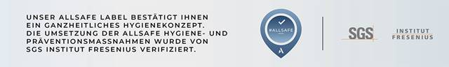
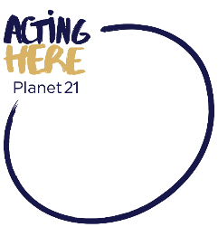
Our hotel Ibis Budget Wien Messe** has been certified according to our ALL Safe hygiene concept and participant in ACCOR`s own environmental program Acting Here - Planet 21.

Hotel | Date | Price incl. breakfast
Ibis Budget Wien Messe**  Lassallestrasse 7, 1020 Wien  Reservation:  Ms Mag. Lieselotte DAICHENDT  Tel: +43 1 212 04 24  E-Mail: H7098-RE@accor.com | 02 April 2023  -  08 April 2023 | 75.00 EUR  Per Standard Double Room for Single Use / Night  *  83.50 EUR  Per Standard Double Room for Double Use / Night

Zahlungs- und Buchungskonditionen/ Booking and Payment Conditions
- Payment direct at the hotel. For payment and booking guarantee a credit card number with expiry date is compulsory to qualify the booking. Cancellation free of charge is possible until 7 days prior arrival. In case of early departure, late cancellation, or No-Show, 100 % of the gross total amount will be charge from your credit card.
Check in / Check:
- Check in from 2pm
- Check out until 12am.

In case of early arrival or late departure, with pleasure group can storage their luggage free of charge – on request and availability.

Important Information for your arrival due COVID- 19 - VIENNA
There are currently no known measures for the above period.

We would like to point out that you should inform yourself about the current entry conditions before you start your journey on time .

